In Search of ‘Good’ Energy Policy
Energy@Cambridge IRC

Final Report

This report is intended to summarise the achievements of the In Search of ‘Good’ Energy Policy (GEP, for short) Grand Challenge Initiative of the Energy@Cambridge Interdisciplinary Research Centre (IRC).

The project has been running since November 2014, when it was formally adopted as a Grand Challenge initiative by Energy@Cambridge and finished in September 2019.

It has been a significant undertaking led by over 20 academics (over the five years) from at least 12 different university departments. It has run 56 Centre for Research in the Arts, Social Sciences and Humanities (CRASSH) seminar events regularly attracting audiences of between 20-40 people, both from the university and external members of the public. The final steering group (by September 2019) consisted of 19 individuals representing 9 university departments (Management, Economics, Land Economy, Law, Geography, Psychology, Divinity, Politics and International Studies and History).

Over the years we have received the following financial support:
£80,000 from The Higher Education Innovation Fund (HEIF), £10,000 from the Energy Policy Research Group (EPRG), £5,000 from the Newton Trust, £2,000 from the EPSRC Global Challenges Research Fund, £2,000 from the ESRC Impact Acceleration Award and contributions in kind from the Foreign and Commonwealth Office (FCO) (through its Embassy in Beijing and Consulates in Guangzhou and Shanghai), from National Grid (though support for the travel of Lewis Dale on two GEP trips to China in November 2016 and March 2019) and from the University of Hong Kong (to fund studentships and a post-doc).

Activities of GEP
The project started life with the encouragement of Dr Rob Doubleday, Centre for Science & Policy (CSaP), Prof Martin Daunton (Head of the School of the Humanities and Social Sciences) and Dr Isabelle de Wouters (Director Scientific Development of Energy@Cambridge) in September 2014, which led to a proposal to Energy@Cambridge in November 2014. The project was launched in January and February 2015 with an initial round of 16 interviews with individuals interested in energy policy in different university departments. Most of these individuals went on to become members of the GEP Steering Committee, which met once a term. Prof David MacKay gave the opening address at a launch workshop in March 2015.

We had initial discussions with DECC, CSaP, BP, HM Treasury, Ofgem, Government Office for Science, Friends of the Earth, Shell, Element Energy, Utilitywise, Nato/Ministry of Defence as a part of broader outreach activities.

In Search of ‘Good’ Energy Policy hosted an event at the 2015 University of Cambridge Festival of Ideas on the Geopolitics of European-Russian Energy relations.

Our CRASSH seminar series began in October 2015 and ran for four years until June 2019. In total we had 50 speaker seminars and 56 meetings in all including a termly Ideas meeting, which was introduced in 2018, in one of the CRASSH seminar slots.

We have had an ongoing relationship with the Department of Electrical Engineering, University of Hong Kong (HKU), with periodic visits of each to the other. HKU established the HKU-Cambridge Clean Energy Platform in November 2015 (led by Professor Victor Li and Dr Jacqueline Lam at HKU). They agreed to fund up to two annual studentships for M.Phil. in Technology Policy (the first student has just completed his M.Phil. in 2018-19. This arose from high level support for GEP from the Vice-Chancellor of the University of Hong Kong. They also provided funding for a post-doc (Dr Jacqueline Lam) to work on UK-China Clean Air Act comparison and on other joint papers on Chinese clean air policy.

We have continuing impact supported by the Foreign and Commonwealth Office (FCO) on Chinese power market reform since the October 2015 State visit of President Xi to the UK. Around the time of the visit Professor Pollitt chaired a session at the UK-China Annual Energy Dialogue run by the Foreign Office, on Electricity and Gas market reform, with senior representatives from China, include Director General Liu Deshun from the National Energy Administration of China. National Grid, Ofgem and British Embassy in Beijing supported trips to China (8), 3 papers (and a book). This work has attracted additional funding from the ESRC Global Challenges Fund, EPSRC Travel Grant and EPSRC Impact Acceleration Account. On 12 May 2017 we held a joint conference with the FCO in Cambridge on ‘Chinese Power Market Reform and Opportunities for UK Business’, with 60 delegates from government, industry and academia. We have collaborated with National Grid, who sent Lewis Dale (their Regulation and Strategy Manager) to accompany us on two trips to China to discuss lessons from UK power market reform with stakeholders in China. We facilitated Ofgem’s participation with the British Embassy in helping to design a new renewables support scheme in China and have been discussing a UK-China Training Course for electricity professionals (from Chinese companies and regulatory agencies) led by Professor Furong Li at the University of Bath, which has recently received an £16,000 funding (in May 2019) from the British Embassy in Beijing.

Energy@Cambridge hosted a round table discussion with Carlos Moedas, Commissioner for Research, Science and Innovation at the European Commission, in March 2016. The discussion was chaired by Prof Sir Richard Friend, Director of the Maxwell Centre, and attended by members of the Energy@Cambridge Steering Committee and academic community, including GEP’s Prof Paul Warde. The purpose of the roundtable was both to inform Commission Moedas of energy-related research capabilities at Cambridge and to help shape the European Commission’s thinking and provide useful input into the EC cabinet’s EU energy research strategy.

Dr David Reiner travelled to Singapore in April 2016, as part of GEP, in order to provide advice on how to bring social science into phase two of the CREATE activity in Singapore. David met with the Energy Institute, National Climate Change Secretariat and Energy Markets Authority. This facilitated the successful involvement of Prof Steve Evans in phase two of the bid. Some CREATE projects have been extended whilst others have been terminated. This activity has led to bridges across Energy@Cambridge Grand Challenges.

In November 2016, the Business, Energy and Industrial Strategy (BEIS) Committee launched an inquiry: Leaving the EU: negotiation priorities for energy and climate change policy. Drawing on academic research and expertise across the University, the IRC co-ordinated the University’s submission to BEIS. Resulting in a request to the Pro-Vice Chancellor for Research’s Office that the University participate in a public evidence session in March 2017 to discuss the wider implications, opportunities, and models of UK-EU energy relations on the future UK energy system.
http://www.parliamentlive.tv/Event/Index/14776e7e-ab77-41bf-ac58-7580c032b6e8

On 3 March 2017 we held an outstanding Faith, Energy and Society Workshop. This event was organised by Dr Jonathan Chaplin (Faculty of Divinity) and supported by other colleagues from GEP. This had speakers from Christian, Islamic, Jewish, Buddhist and Hindu perspectives with 70 attendees, leading to a 5 page summary of the event available and a paper.

In 2015 a delegate from the French embassy in London spoke at one of our CRASSH seminars and this gave rise to an idea for a conference on the Ethics of Nuclear Power. This eventually resulted in a meeting on 15 May 2017 on Nuclear Power and Ethics/Philosophy in Oxford with participation from Dr Leslie-Anne Duvic-Paoli and Cambridge students.

GEP also supported the launch on 21-22 June 2017 of a Platform on International Energy Governance led by the Cambridge Centre for Environment, Energy and Natural Resource Governance (CEENRG).

GEP hosted a number of stakeholder visits to Cambridge including the National Infrastructure Commission, Ofgem, Statoil (this resulted in an ongoing collaboration with the Norwegian University of Science and Technology) and UBS. We also facilitated the introduction of Trafigura to Cambridge Energy Partners (a start up from Judge MBAs), which resulted in a senior Trafigura executive, Michael Davies, becoming Chair of their board.

GEP has launched two Small Grants Scheme calls in May 2018 (funded by the Newton Trust/EPRG) and March 2019 (funded by EPRG). These projects had to involve participants from at least two Cambridge departments, and were aimed at promoting interdisciplinary linkages across the university in energy policy. Most of funding has gone to PhD students and early career researchers.

The initial round of projects funded were:
- Interdisciplinary perspectives on the economic evaluation of energy generation projects: Ida Sognnaes (Land Economy) & Lucy Goodman (Geography)
- Case study on Azuri Technologies and catalyzing dialogues for addressing technological and socioeconomical barriers to sustainable energy-transition: Arfa Karani (Physics) & Yi Lei Tan (Biochemistry)
- ‘Good’ energy-water-food nexus policies in Latin America: Dr Pablo Salas (Land Economy) & Dr Sanna Markkanen (Cambridge Institute for Sustainability Leadership, CISL)
- Energy trade, carbon transfer and China’s changing role in global energy governance: Chung-Han Yang (Land Economy) & Dr Jing Meng (POLIS)
- The role of Chinese manufacturing in the selection of technologies and devices related to energy services brought to developing-country projects: Karla Cervantes Barrón (Engineering) with supervision from Prof Laura Diaz Anadón (Land Economy) and Dr Jonathan Cullen (Engineering)

The second round of projects funded were:
- Inclusive, resilient and sustainable development and large energy infrastructure in the Greater Mekong Basin (seed funding for network): Dr Yan Zhang (POLIS) and Dr Christopher Schulz (Geography).
- Lithium and its role in the low-carbon energy transition: materiality, geopolitics and technology: Dr Maria Daniela Sanchez-Lopez (Newnham College) and Dr Pablo Salas (Land Economy).
- Roundtable Workshops for the Cambridge Infrastructure Resilience Group (CIRG): Alexander Taylor (Social Anthropology), Henri van Soest (Land Economy) and Julius Weitzdörfer (Law).
- The Green ENergy Index (GENI): Measuring the global contribution of countries to the clean energy transition: Oliver Taherzadeh (Geography), Benedict Probst (Land Economy) and Hyesop Shin (Geography).

Outputs
The major output of the initiative has been the In Search of Good Energy book produced by Cambridge University Press (CUP). This book involved five editors (from four different departments), 22 chapters and 40 authors from 12 disciplines and 11 universities. This was published by CUP in June 2019. Most of individual case study papers were presented at GEP seminars and two multidisciplinary cases were written as a result of relationships formed through GEP. This book built on a multidisciplinary paper written by nine authors in 2016 on lessons from the 1956 UK Clean Air Act (Chaplin et al., 2016) and on a paper (in English and Spanish) published by Prof Michael Pollitt (based on the initial GEP interviews). The book was launched in September 9th 2019 at an event at the British Academy in London, organised by CSaP.

The Faith, Energy and Society conference led to a paper by Emma Hill and Jonathan Chaplin, which has now been published. This is available on the Energy@Cambridge website.

Our work, in collaboration with the British Embassy in Beijing, on Chinese power market reform has led to three papers, each is available in English and published in Chinese (translated by the British Embassy in Beijing). These papers will form the basis of a book (edited by Prof Michael Pollitt) on Restructuring the Chinese Electricity Supply Sector to be published by Palgrave in early 2020. A paper summarising the lessons from our conference with the British Embassy in Beijing is available on the Energy@Cambridge website. An Impact through Engagement video on this work is available on the University’s public Research Strategy webpages.

Our work with the University of Hong Kong has resulted in further work on air pollution in Beijing, recently published as an EPRG Working Paper.

We have produced 46 podcasts and 42 videos based on the presentations given at the GEP seminar series at CRASSH. These are available on the Energy@Cambridge Website. https://www.energy.cam.ac.uk/good-energy-policy/in-search-of-good-energy-policy-videos-and-media

Significant Achievements
We would highlight three major achievements of the initiative.

- We have created a community of scholars at Cambridge willing to work with one another on multi-disciplinary projects. Several of these have been promoted and now left Cambridge to continue their careers elsewhere. A good number of PhD students and post-doctoral researchers have been supported in their multi-disciplinary research projects. The EPRG is committed to continuing to fund multi-disciplinary research and engagement projects through the continuation of the small grant fund.

- We have had a significant disciplinary reach for one project, successfully bringing together disciplines as diverse as theology, philosophy, history, law, political science economics and engineering. Indeed one of the standout features of the project has been extending inter-disciplinary understanding beyond closely interacting disciplines and departments (such as political science and economics). Our book remains a unique contribution to celebrating inter-disciplinarity in energy policy.

- Our work on Chinese power market reform and Chinese air pollution has pushed the reach of GEP internationally. It has been recognised by the National Development and Reform Commission (NDRC) in a press release and has attracted significant support from the British Embassy in Beijing and the British Consulates in Guangzhou and Shanghai and from National Grid. We have also had a significant collaboration with the University of Hong Kong: they continue to host the HKU-Cambridge Clean Energy Platform and to fund up to two of their students to attend the M.Phil. in Technology Policy, at Cambridge.

Closing Thanks
I would wish to express my sincere personal thanks to Dr Isabelle de Wouters, Dr Shafiq Ahmed and Raheela Rehmen from Energy@Cambridge for their support over the last five years. Their support for the project has been invaluable and significantly enhanced the project’s success and facilitated a collaborative working environment. Without them the project would not have been sustained for so long – thank you very much.

It almost goes with saying that I am also very grateful to many of my colleagues that have supported the project and contributed to its success. Special mention goes out to Dr Marc Ozawa who was the post-doc on the project for its first year and who was the managing editor of the GEP book, Prof Tim Lewens of CRASSH, Prof Jorge Vinuales (who edits the series in which our book is in) and Dr Rob Doubleday at CSaP for his initial encouragement and facilitation.

We gratefully acknowledge our funders: HEIF, University of Hong Kong, ESRC, EPSRC, EPRG, Newton Trust, FCO and National Grid.

Prof Michael Pollitt
Chair of In Search of ‘Good’ Energy Policy initiative
19 September 2019

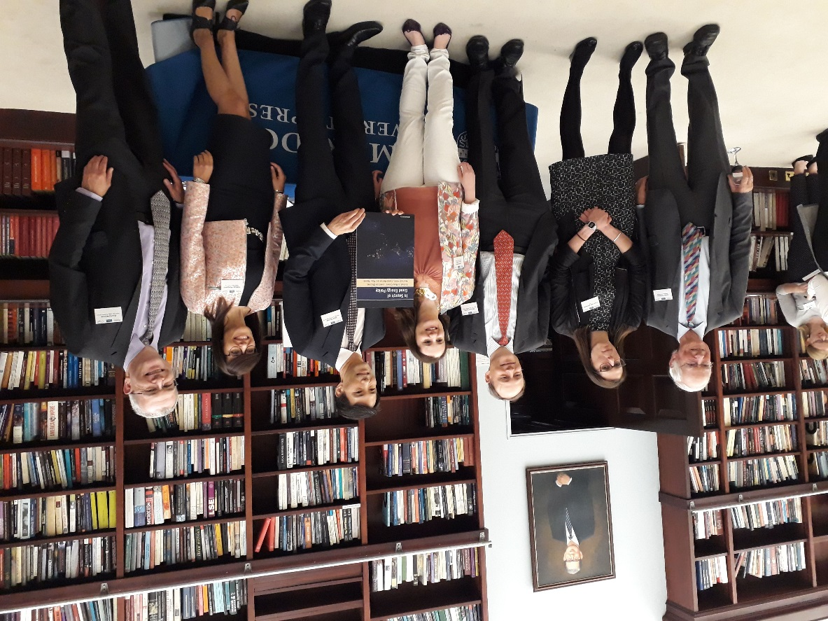

GEP Output References
Chaplin, J., Lewens, T., Newbery, D., Ozawa, M., Pollitt, M.G., Reiner, D.M., Viñuales, J.E., Warde, P., de Wouters, I. (2016), In Search of ‘Good’ Energy Policy: Multi-disciplinary approaches to the UK’s 1956 Clean Air Act, Mimeo, May 2016.
Han, Y., Li, V.O.K., Lam, J.C.K., and Pollitt, M. (2019), How BLUE is the Sky? Estimating the Air Quality Data in Beijing During the Blue Sky Day Period (2008-2012) by the Bayesian LSTM Approach, EPRG Working Paper 1912.
Hill, E. and Chaplin, J. (2017), Harnessing religious energies for better energy policy, KLICE Comment August 2017,
Ozawa, M., Chaplin, J., Pollitt, M., Reiner, D., Warde, P. (eds.) (2019), In Search of Good Energy Policy, Cambridge: Cambridge University Press. (398pp)
Pollitt, M. and Dale, L. (2018), Restructuring the Chinese Electricity Supply Sector – How industrial electricity prices are determined in a liberalized power market: lessons from Great Britain, EPRG Working Paper, No.1839. Forthcoming in Chinese in Financial Minds. Available in Chinese at: https://www.eprg.group.cam.ac.uk/wp-content/uploads/2018/11/1839-Text_ChineseV.pdf
Pollitt, M., Yang, C-H, and Chen, H. (2018), ‘Restructuring China’s Power Supply Industry: Pilot Evaluation of Guangdong Power Market’, Financial Minds, Vol. 3 Issue 6, pp.107-135, November 2018, National Academy of Economic Strategy, Chinese Academy of Social Sciences [in Chinese]. Available in English as Pollitt, M., Yang, C-H and Chen, H. (2018), Restructuring the Chinese Electricity Supply Sector: An assessment of the market pilot in Guangdong Province, EPRG Working Paper, No.1807.
Pollitt, M., Yang, C-H, and Chen, H. (2017) ‘Electricity Reforms: International Experiences and China’s Decision’, Financial Minds, Vol. 2 Issue 4, pp.5-81, July 2017, National Academy of Economic Strategy, Chinese Academy of Social Sciences [in Chinese]. Available in English as Pollitt, M.G., Yang, C-H., and Chen, H. (2017). Reforming the Chinese Electricity Supply Sector: Lessons from International Experience, EPRG Working Paper No.1704.
Pollitt, M. (2016), ‘In Search of ‘Good’ Energy Policy: the Social Limits to Technological Solutions to Energy and Climate problems’, Papales de Energia, No.1 (February), pp.111-140. (also in Spanish on pages 9-42).

