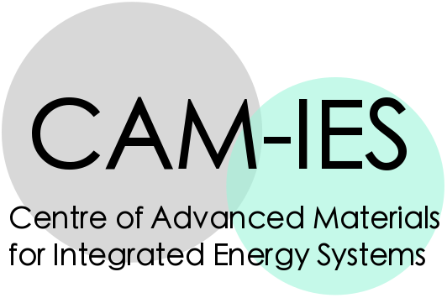

Abstract Submission Form for The CAM-IES Early Career Workshop, Queen Mary University of London, 3 September 2019

Are you a PhD, postdoc or advanced fellow in energy materials? Are you an early user of a novel characterisation technique? Submit an abstract to the CAM-IES Early Career Workshop to give a short talk or poster to promote your technique to other early career researchers in the UK energy materials community!

TALKS

Talks are 10 minutes long with 5 minutes for questions. Talks should have an introduction to the novel technique, characterisation tool, or modified equipment that you are using in your research. Talks should be aimed at a scientific audience with no specialist knowledge of your technique or research area.

POSTERS

Posters are A0 portrait, and should highlight the principal operation and applications of your novel technique, how it differs from conventional modes of operation, and what impact it could have on your research field, and other energy materials systems.

Please send your abstract using this application form to Lata Sahonta sls55@cam.ac.uk by 12pm on Monday 8 July 2019. Late abstracts may be considered for poster presentations only.

CAM-IES will reimburse travel expenses for all speakers and poster presenters travelling to this workshop from outside of London. For more information please contact Lata Sahonta sls55@cam.ac.uk

INFORMATION ABOUT YOUR CHOSEN CHARACTERISATION EQUIPMENT

Please expand content fields as required.

Your Name, Department, Institution, email address

Your supervisor’s Name, Department, Institution, email address
(if applicable)
Name and address of your equipment item, Research Group, Laboratory, Department, Institution
Name of Academic Equipment Owner, Technician and/or Facilities Manager
(if applicable)
Details about the equipment | This equipment is part of:  A National Facility  Henry Royce Institute  Other UK Shared Equipment  Only currently shared within my Department or University  Only currently shared within my research group  (please delete as appropriate)

PRESENTATION TYPE (please delete as appropriate)

I wish to present a talk to showcase my research technique (Talks must be 10 minutes + 5 for questions)
I wish to present a poster to showcase my research technique (A0 portrait size)

Abstracts not accepted for talks will be automatically offered poster presentations.

ABSTRACT

This section must be up to one page long. Please use this section to describe your technique. Try to answer some of the following questions when writing your abstract.
- What is the basic principal of operation of your technique?
- How does this technique aid characterisation in your research area?
- Why are its capabilities novel and unique in comparison to conventional characterisation techniques in your research area?
- Can it be easily set up by modifying conventional laboratory equipment, or do you have a dedicated instrument?
- What new results has this technique allowed you to obtain that are of significance to your research area?
- What benefit could this technique present to a different materials community (or multiple communities) separate from your own?

