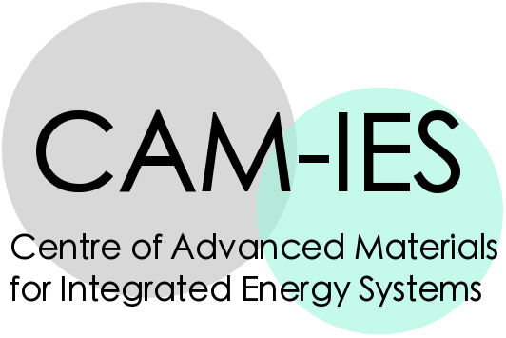

EPSRC grant "Centre for Advanced Materials for Integrated Energy Systems (CAM-IES)" EP/P007767/1
Cambridge Royce facilities grant EP/P024947/1

Application for funding to support Cambridge Royce facilities access costs

The EPSRC Centre of Advanced Materials for Integrated Energy Systems (CAM-IES) will provide funding to support access to shared equipment facilities by academic and postdoctoral investigators from its four member institutions (University of Cambridge, Queen Mary University of London, UCL, Newcastle University).
Applicants are invited to submit proposals for award of this flexible funding, to provide access to the newly-installed Henry Royce Institute facilities at the University of Cambridge.
This call is ongoing. Proposals may be submitted at any time during the year until 30 April 2019, and proposals will be reviewed every two months.
Please use this section to write your proposal (up to one page).
Please include the following:
•Project structure e.g. aims, objectives, deliverables
•Facilities access required, including estimated cost
•How the project demonstrates synergy between energy materials topics
•Impact of the project on current energy technologies
•Discussion with Royce technical staff about experimental design and risk assessments is required prior to submission.

Applications must be signed by a Royce academic lead and/or an appropriate member of Royce technical staff.

Please email the completed form to Dr Lata Sahonta sls55@cam.ac.uk (please expand content fields as required. Proposal section must be no longer than one page)

INFORMATION ABOUT APPLICANT

Name, Department, University of applicant (postdoctoral applicants must include an academic co-investigator)
Name, Department, University of user(s) (may include MRes/PhD students)
Royce item(s) of interest (consultation with Royce technical staff prior to submitting application is highly advised)
Estimated cost of usage of Royce facilities
Estimated cost of travel, subsistence
Estimated cost of small consumables necessary to project
Other project estimated costs
Total project proposed cost

Discussion with Royce technical staff about experiment design, chemical safety and risk assessments is required prior to submission.  Applications must be signed by a Royce academic lead or an appropriate member of Royce technical staff. | Signature of Applicant | Signature of Royce Academic Lead  or relevant Royce Technical Lead

PROPOSAL

